JS Back-End Exam – Course Book

Exam Rules:
- You have 4 hours.
- When you are ready, delete the node_modules folder, make sure all dependencies are listed in the package.json file and submit your archiving project.
- You must use the provided HTML & CSS resources.
- You may add attributes (such as class and dataset), but it is forbidden to change existing attributes (such as class and id).
- You may change "href" attributes on links and add/change the method and action attributes of HTML Forms.
- Use Express.js as a back-end framework.
- Use MongoDB as a database with mongoose.
- You can use whatever view engine you like (express-handlebars, EJS, Pug, etc.).
- Use bcrypt for hashing the password.
- It is forbidden to use React, Vue, Angular, etc.
- All applications will be examined as follows:
  - The needed dependencies are installed with the command "npm install".
  - The application is started with the command "npm run start".
- The examiners are NOT allowed to change anything in your code and will NOT use any instruments outside of the course scope.
IMPORTANT:
1. THE APPLICATION MUST START FROM THE FILE "INDEX.JS" ON PORT 3000!
2. ONLY THE LAST SUBMISSION WILL BE EVALUATED!

Application Overview
Get acquainted with the provided HTML and CSS and create an application for the course posts.
The visitors can view the Home page and All Course page with available courses. They can also register with an email, username, and password, allowing them to create their offers and to sign up for a course they are interested in (if the current user is not the author of the offer). Authors can edit or delete their courses at any time.

Functional Requirements

Guest (Not logged in)
Guest navigation example:
The application should provide Guest (not logged in) users with the functionality to Login, Register, and view the Home page, All Course page, and Details page.

Users (Logged in)
User navigation example:
The application should provide Users (logged in) with the functionality to:
- View the Home page and all other pages with logged-in navigation
- View Course page
- Create а new Course Offer [Create Course Offers]
- Access course details page [Details]
- Sign up for a course offer (if the current user is not the owner of the course)
- Delete or Edit the course depending on the user's authentication (only for the owner of the current course)

Database Models
The Database of the Course Book application needs to support two entities:

User
- username - string (required),
- email - string (required),
- password - string (required)

Course
- title - string (required),
- type - string (required),
- certificate - string (required),
- image: string (required),
- description: string (required),
- price – number (required),
- signUpList - a collection of Users (a reference to the User model)
- owner - object ID (a reference to the User model)
Note: When a user signs up for a course, their id is added to the signUpList collection. You can add more entities, if you need.
Implement the entities with the correct data types.

Application Pages

Home Page (For logged in users and logged-out users)
Visualize the last 3 added course offers. Each course must show information about the course title, type, certificate and price, as well as a page with details about the specific course.

If there are NO courses in the database yet, display "No course created yet."


Register Page (Logged Out User)
Register a user inside the database with a username, email, and password. The password inside the database must be hashed (use bcrypt), and both passwords must match! After successful registration, you should redirect the user to the Home page. If the user tries to submit invalid data, an error message should be displayed and the already entered data should be kept in the input fields (except for the passwords).
A user who is already logged in should NOT be able to reach this page by typing its URL (e.g. “http://localhost:300/register”) in the browser address bar.
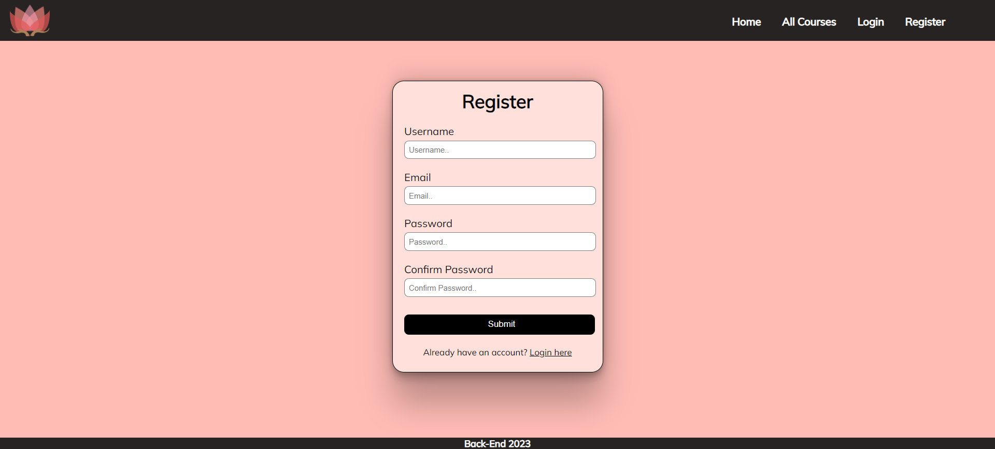

Login Page (Logged Out User)
Logging an already registered user with the correct email and password. After successful login, you should redirect the user to the Home page. If the user tries to submit invalid data, an error message should be displayed and the already entered data should be kept in the input fields (except for the passwords).
A user who is already logged in should NOT be able to reach this page by typing its URL (e.g. “http://localhost:300/login”) in the browser address bar.
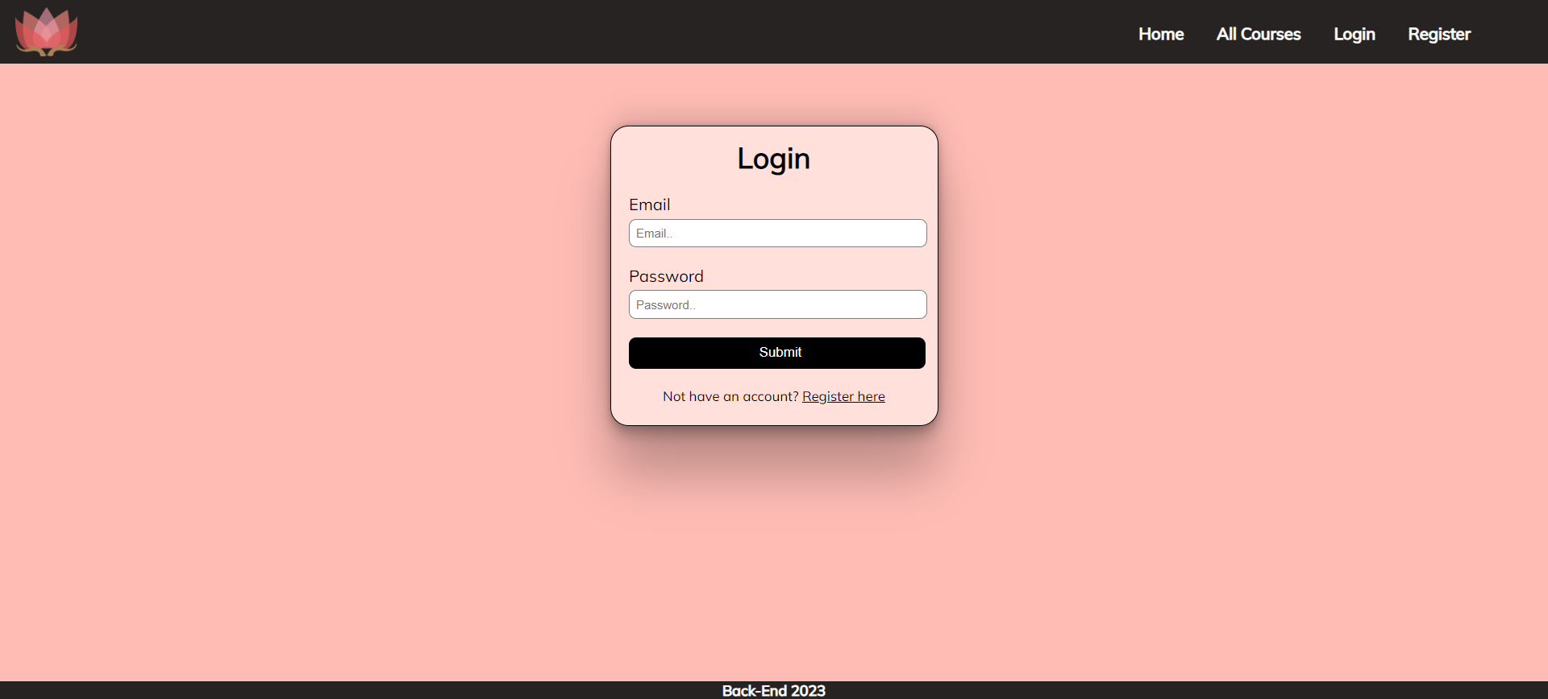

Logout (Logged in user)
The logout action is available to logged-in users. Upon success, clear any session information and redirect the user to the Home page.
A user who is already logged in should NOT be able to reach this functionality by typing its URL (e.g. “http://localhost:300/logout”) in the browser address bar.

Create Course Offer (Logged in User)
The Create page is available to logged-in users. It contains a form for adding new course offers. Upon success, redirect the user to the All Course page. If the user tries to submit invalid data, an error message should be displayed and the already entered data should be kept in the input fields.
A guest user (who is not logged in) should NOT be able to reach this page by typing its URL (e.g. “http://localhost:300/courses/create/1234”) in the browser address bar.
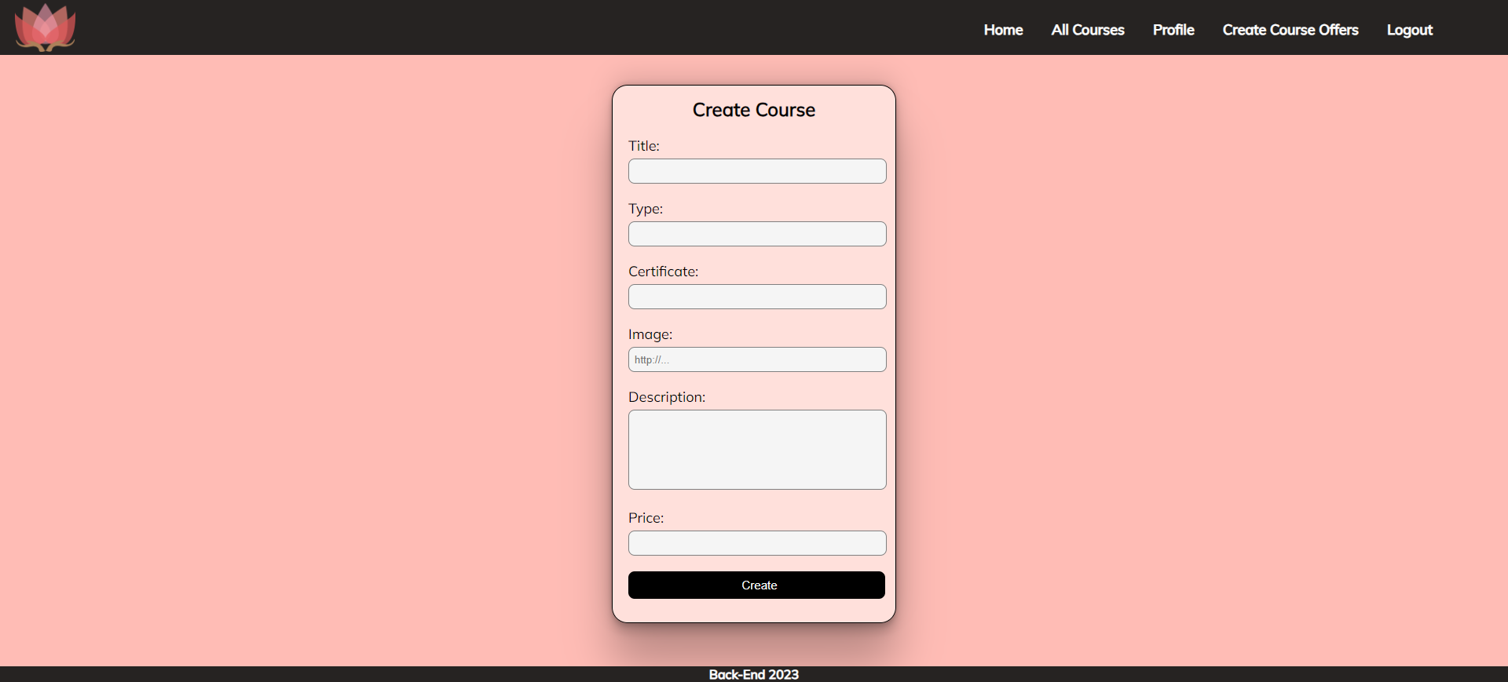

Course Catalog (For logged in users and logged out users)
A list of all course offers. Each course must be displayed with the course image, the title, the type, the price, and a button for details about the specific course. As in the picture below:
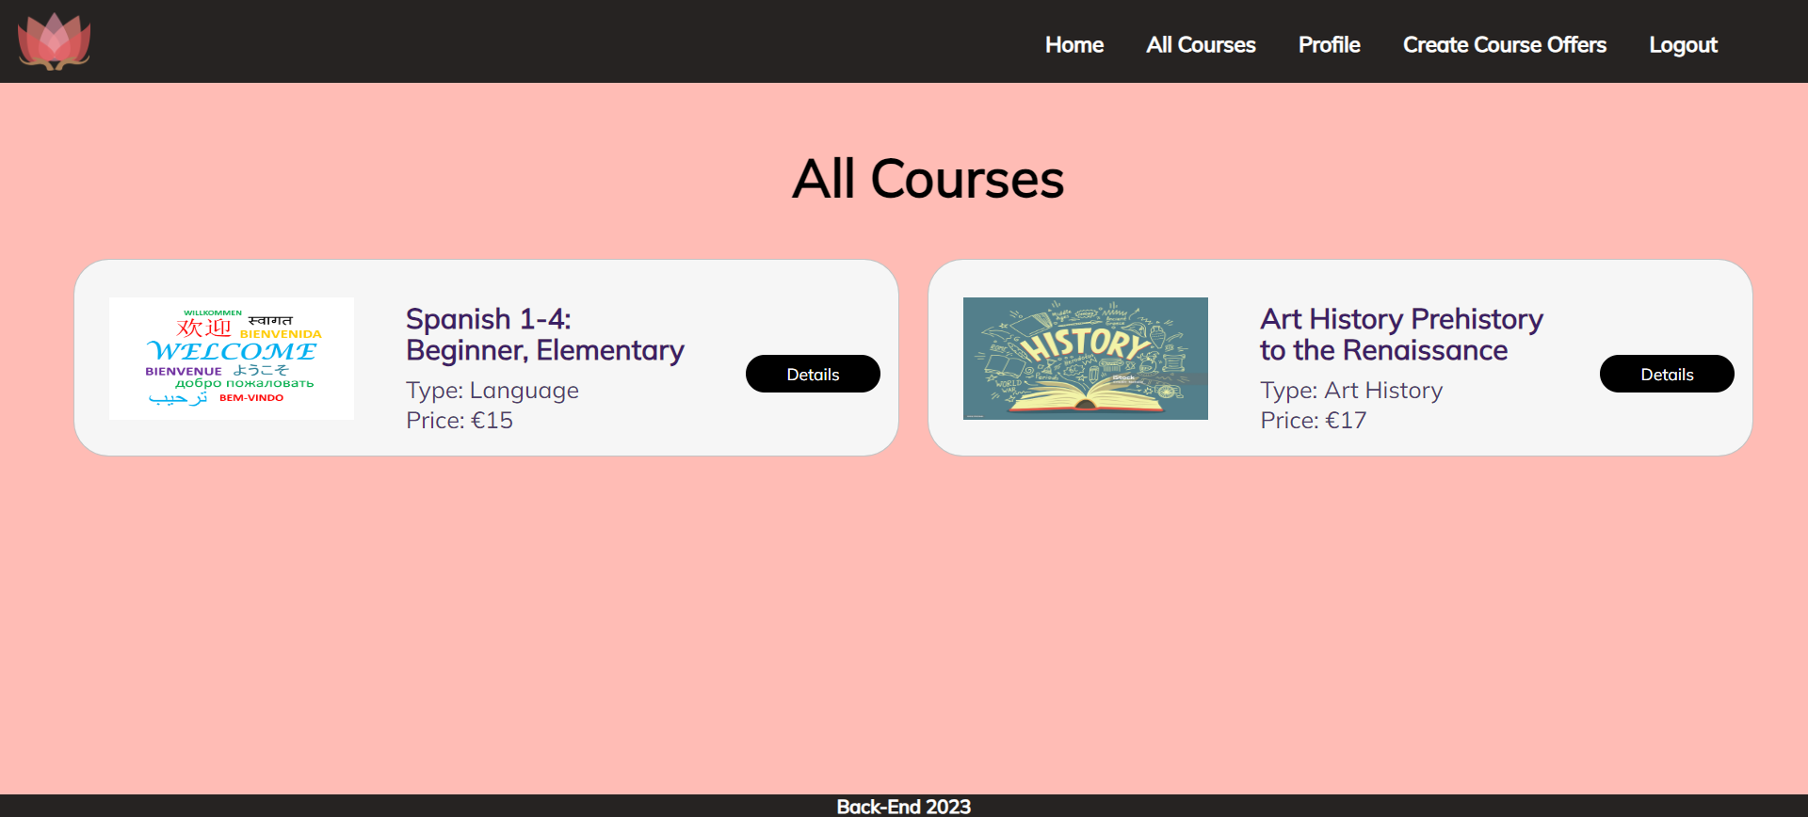
The [Details] button should be a link to the details page for the current course post.
If there are NO offers in the database yet, display "No course created yet."
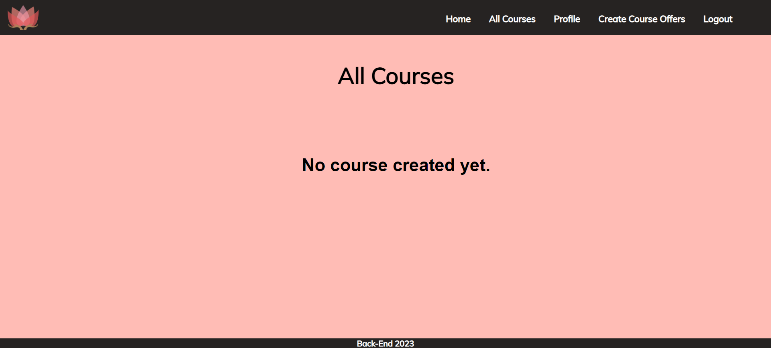

Details Page (For logged in users and logged out users)
All users should be able to see the details about the courses. Clicking the Details button on the course card should display the details page. If the currently registered user is the creator of the course offer, the Edit and Delete buttons should be displayed. Otherwise, they should not be available.
Information about the course:
- Title
- Type
- Certificate
- Price
- Email of the creator
- People who have signed up for this course:
  - If any, separate their usernames with comma and space ", "
  - If not, display "Nobody has signed in for this course yet"
- Description
- Buttons (Depending on the status of the currently logged in user)

Details Page (Logged out users)
If the user has not logged in, no buttons should be displayed.
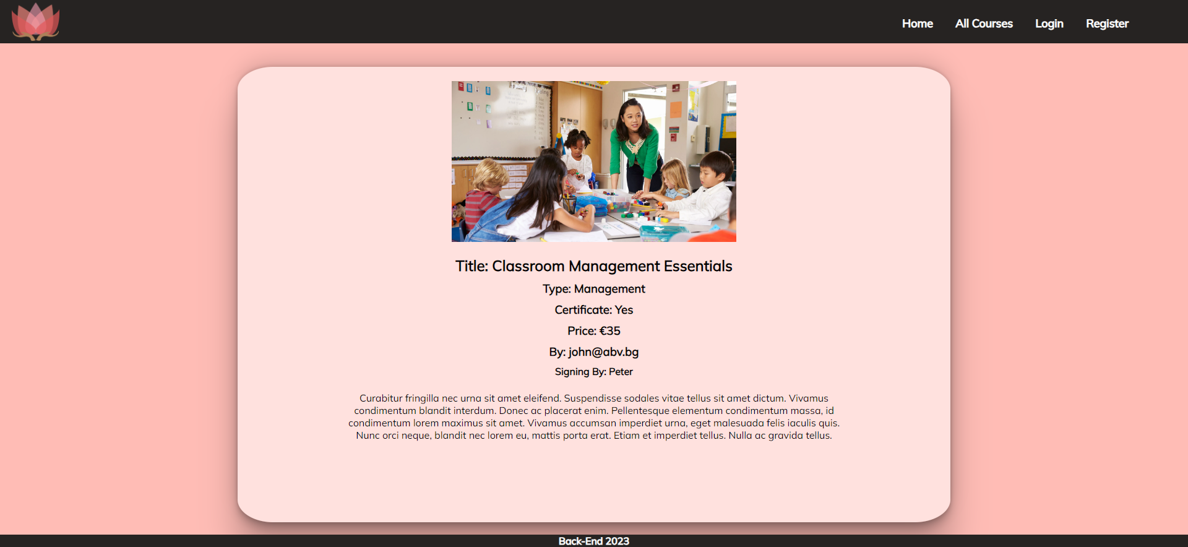

Details Page (Logged in user and creator of the current course)
If the currently logged-in user is the owner (the user who created the course offer), he should see the [Delete] and [Edit] buttons.
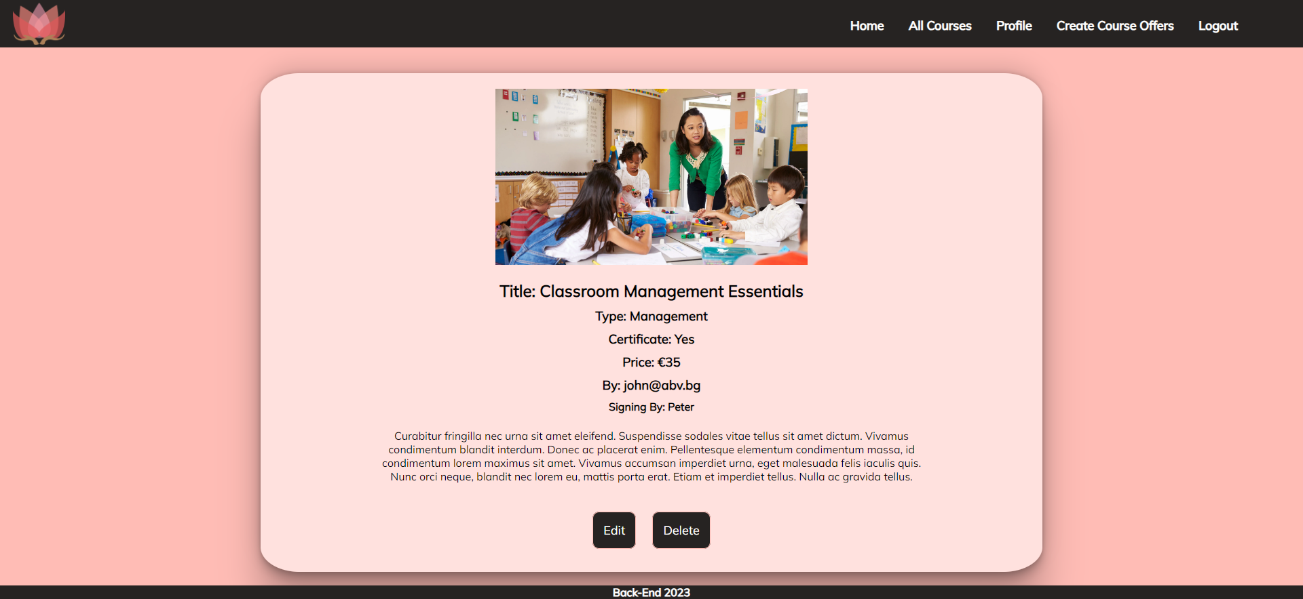

Details Page (Logged in user who is not signed up)
If the currently logged-in user is not the owner (a user who is not the creator of this course offer) and has not signed up for that course, he should see a Sign up button.
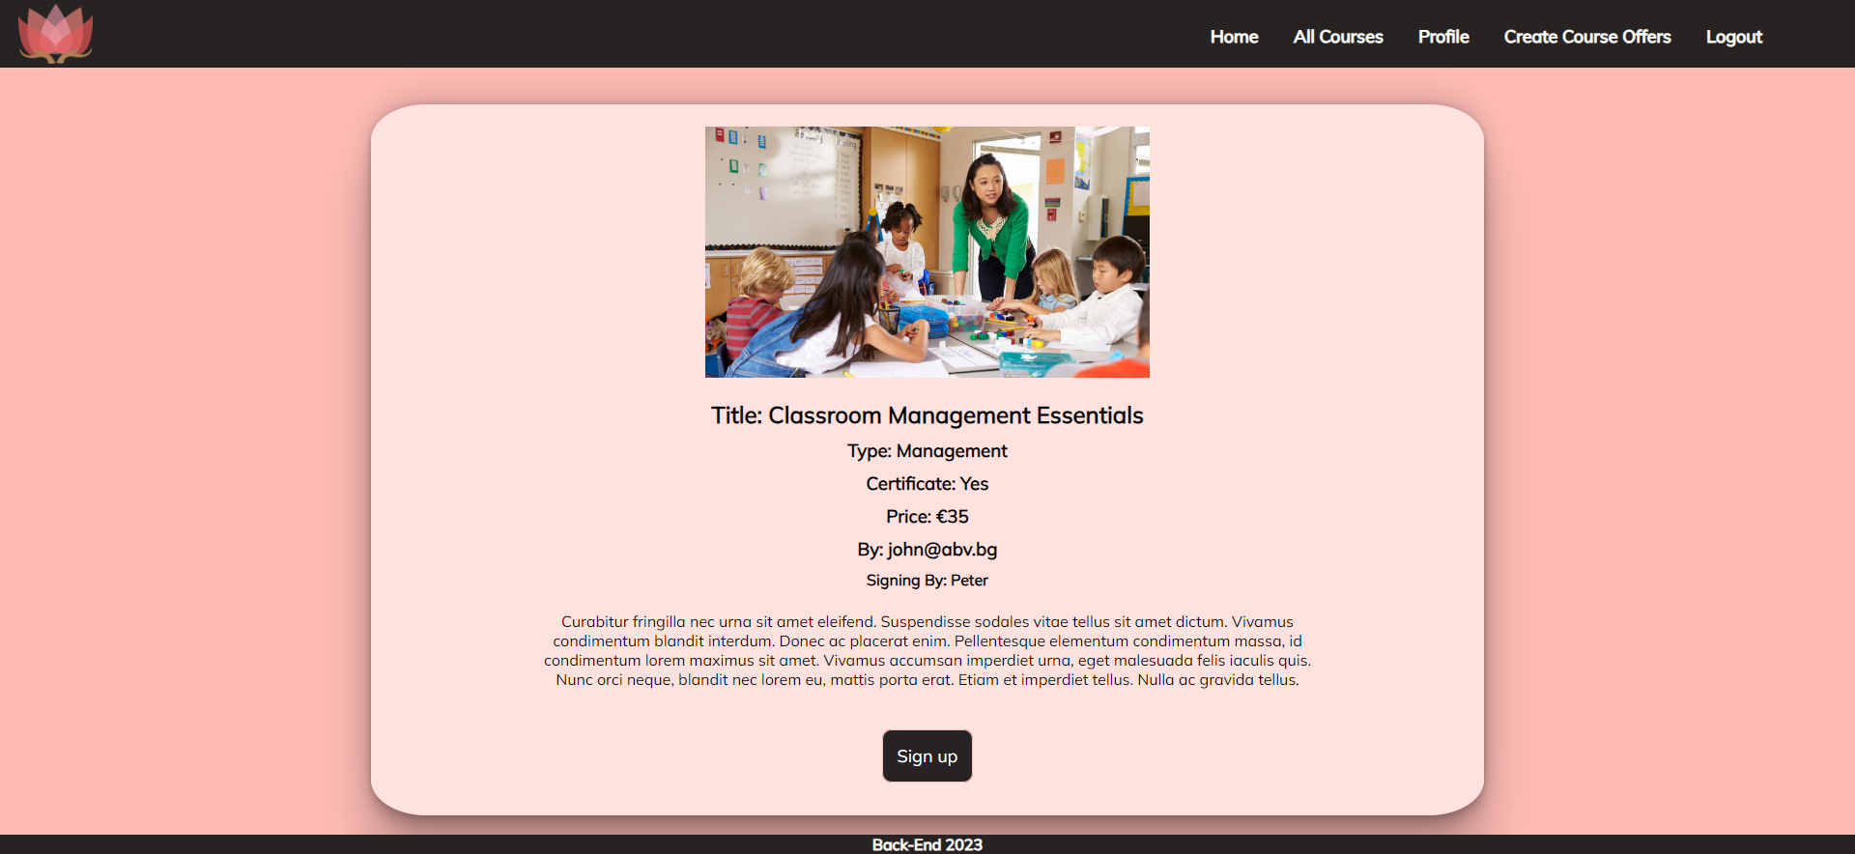

Details Page (Logged in user already sign up for course)
If the currently logged in user is not the owner and has already sign up for that course, he should see [You've already signed up for this course!].
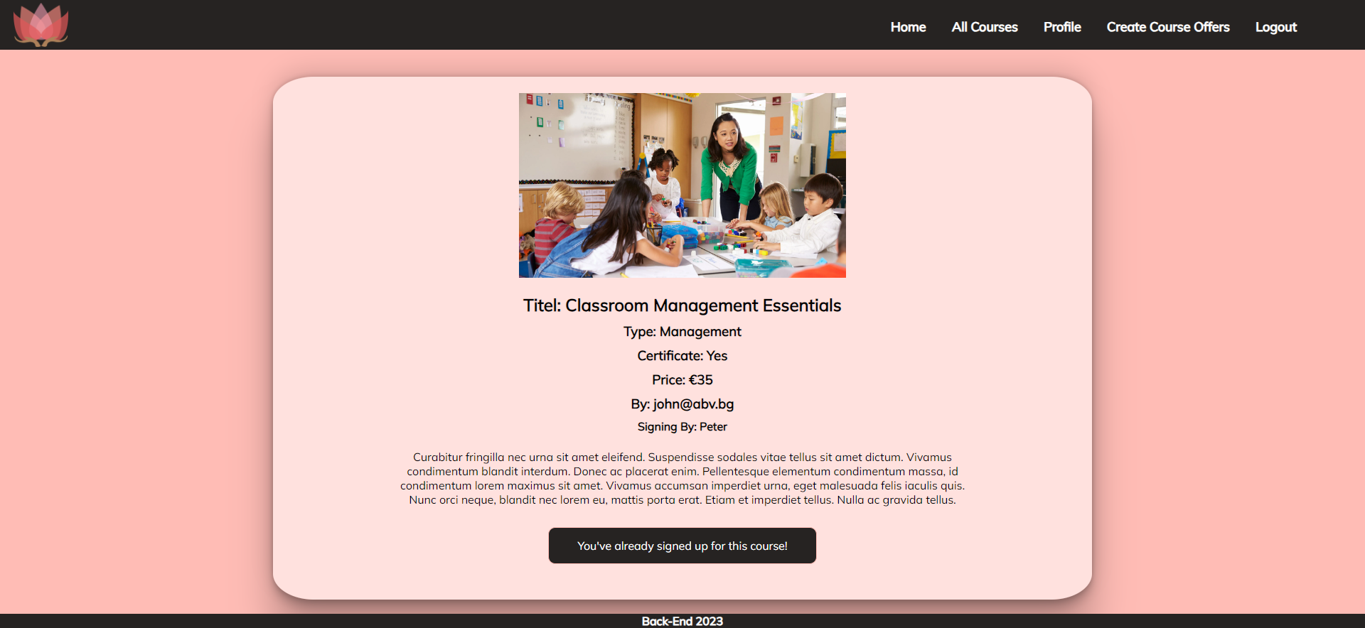

Delete Course (Logged in user and owner of the current course)
Each owner of the course post must be able to click on the [Delete] button and delete the current course from the database. After this, the user must be redirected to the All Course page.
A user who is not the owner of the course should NOT be able to reach this functionality by typing its URL (e.g. “http://localhost:300/courses/delete/1234”) in the browser address bar.

Edit Course (Logged in user and owner of the current course offer)
Each owner can edit their course post. Clicking the [Edit] button for a specific course on the details page should display the Edit page, all fields being populated with course data. It contains a form with input fields for all relevant properties. If successful, redirect the user to the current course post details page. If the user tries to submit invalid data, an error message should be displayed and the already entered data should be kept in the input fields.
A user who is not the owner of the course should NOT be able to reach this page by typing its URL (e.g. “http://localhost:300/courses/edit/1234”) in the browser address bar.
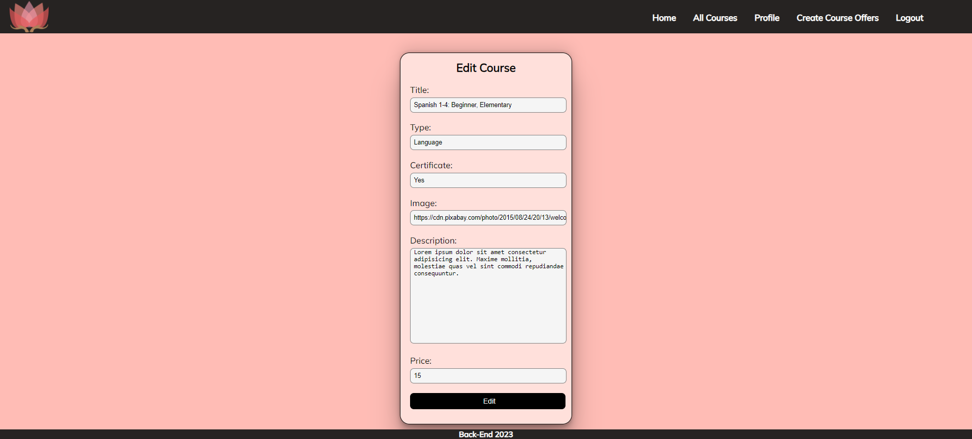

Security Requirements (Routes Guards)
The Security Requirements are mainly access requirements. Configurations about which users can access specific functionalities and pages.
- Guest (not logged in) users can access the Home page.
- Guest (not logged in) users can access the Login page and functionality.
- Guest (not logged in) users can access the Register page and functionality.
- Guest (not logged in) and Users (logged in) can access the All Course Page (Listed all course offers).
- Guest (not logged in) can access the Details page without functionality.
- Users (logged in) can access the Home page.
- Users (logged in) can access the Details page and functionality.
  - Users (not course post owners) can sign up for other courses.
  - Users (course post owners) can Edit and Delete the current course post
- Users (logged in) can access the Profile page and functionality.
- Users (logged in) can access the Create Course Offers page and functionality.
- Users (logged in) can access the Logout functionality.
Use the following view for invalid paths:
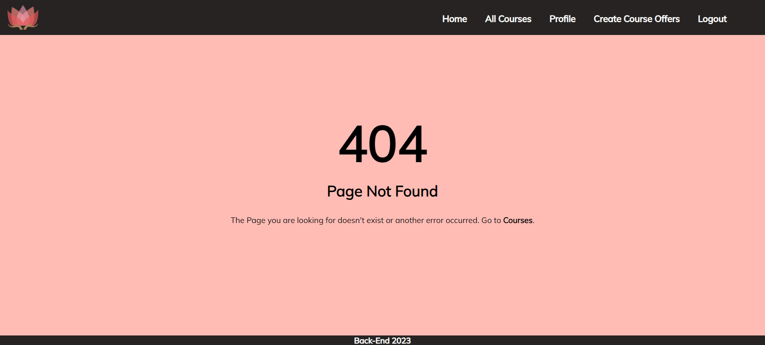

Validation and Error Handling

The application should notify the users about the result of their actions.
In case of error, you should display div with class "errorContainer"

You can choose to display the first error or all of them. You have complete freedom to choose the content of the error message you will display, as long as it is clear what exactly the error is.

Login / Register
You should make the following validations:
- The username should be at least 2 characters long
- The email should be at least 10 characters long
- The password should be at least 4 characters long
- The repeat password should be equal to the password
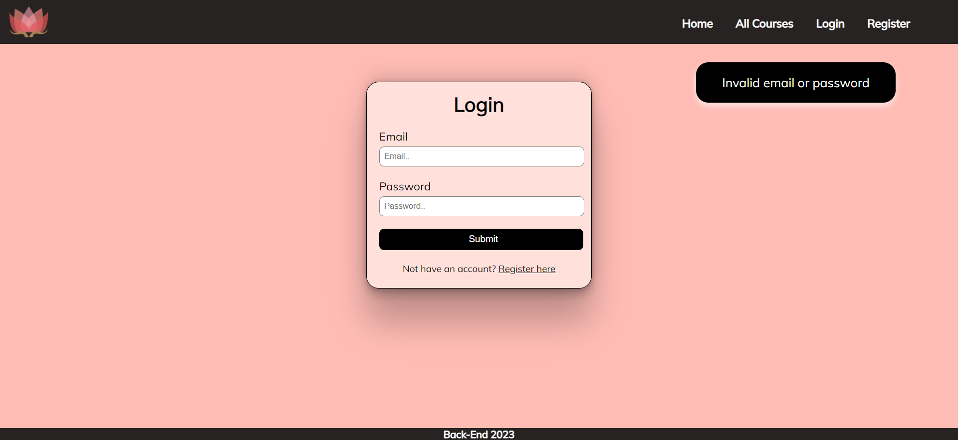

Course
You should make the following validations while creating or editing a course post:
- The Title should be at least 5 characters
- The Course Image should start with http:// or https://
- The Description should be a minimum of 10 characters long
- The Type should be a minimum of 3 characters long
- The Certificate should be a minimum of 2 characters long
- The Price should be a positive number
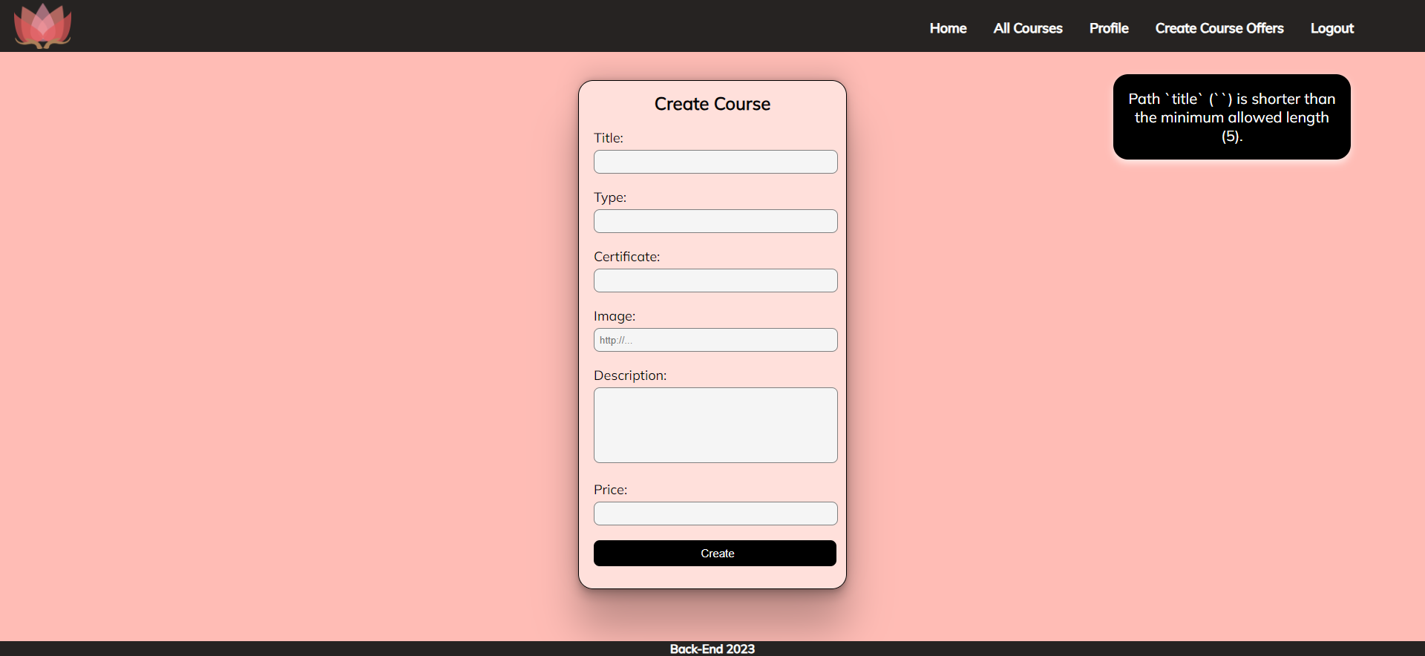

*Bonus – Profile
Each logged-in user should be able to view their profile information by clicking on [Profile]. On the profile page, the user should see their email and the courses they have created, as well as the courses they have signed up for. Under the email, the user has a total count of the created courses and the ones they have sighed up for.
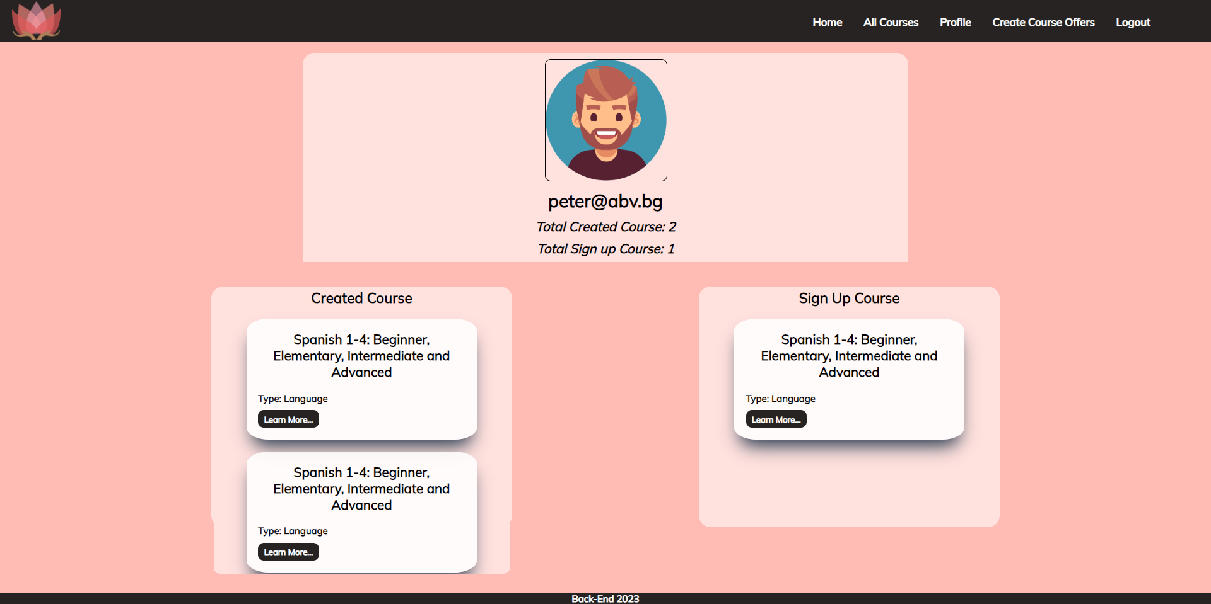
If there are no created courses yet, the message "You haven't created a course yet…" should be visualized.
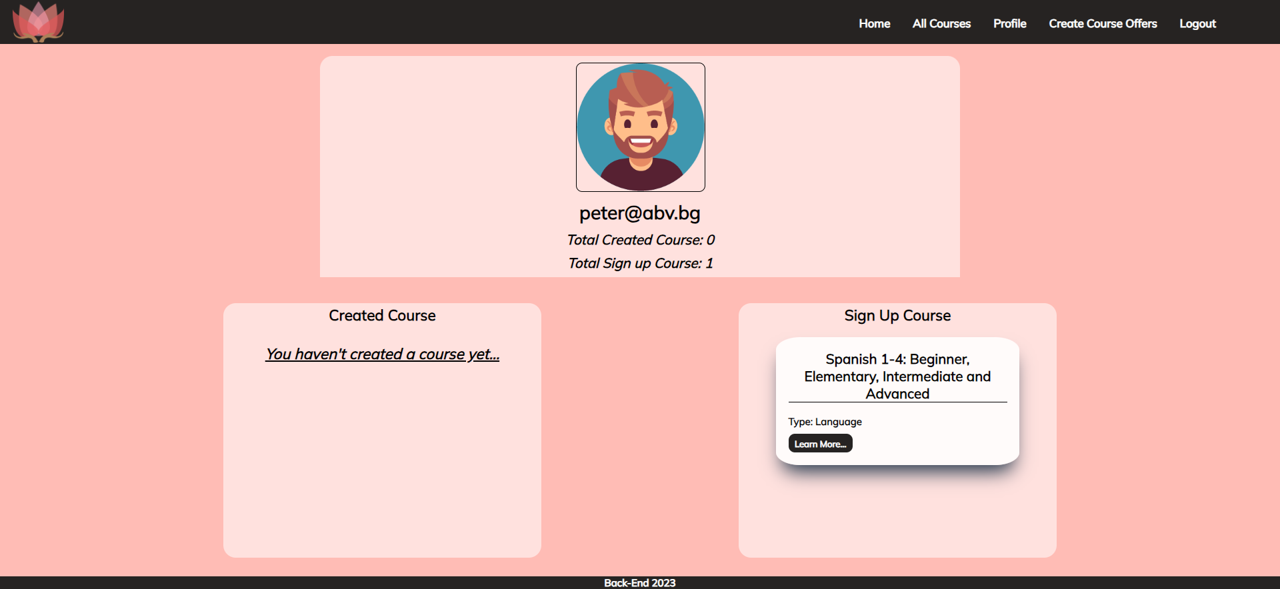
If the user hasn’t signed up for any course yet, the message "You haven't signed up for any course yet…" should be visualized.
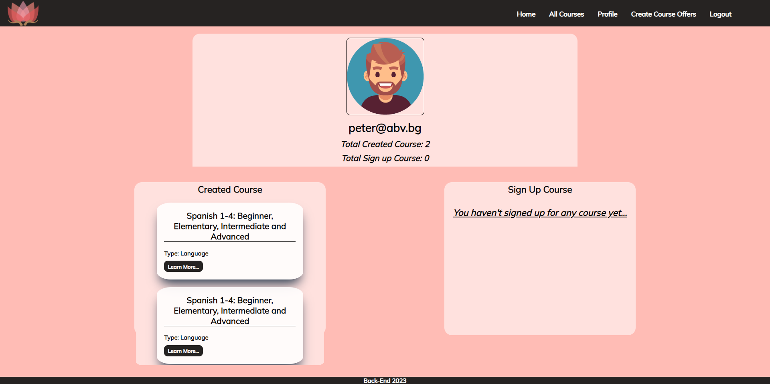

Submitting Your Solution
Place a ZIP file in your project folder. Exclude the node_modules folder. Upload the archive to Judge.
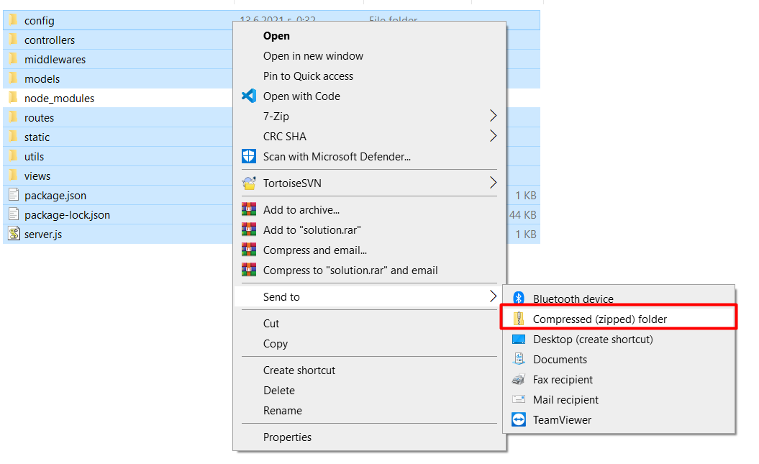
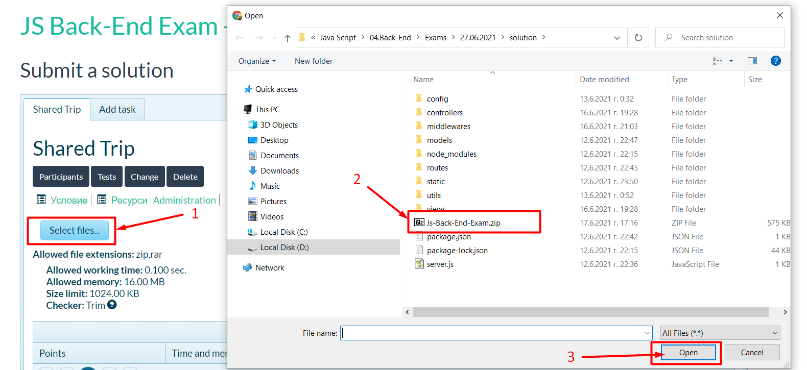
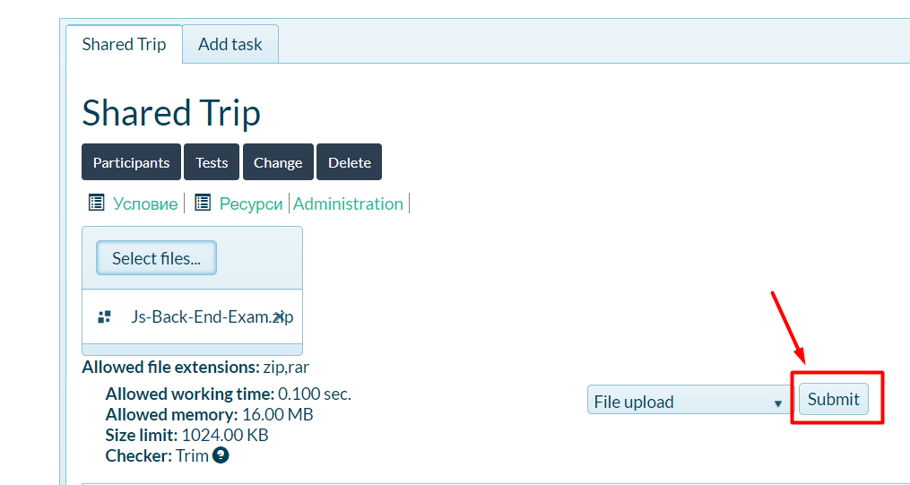
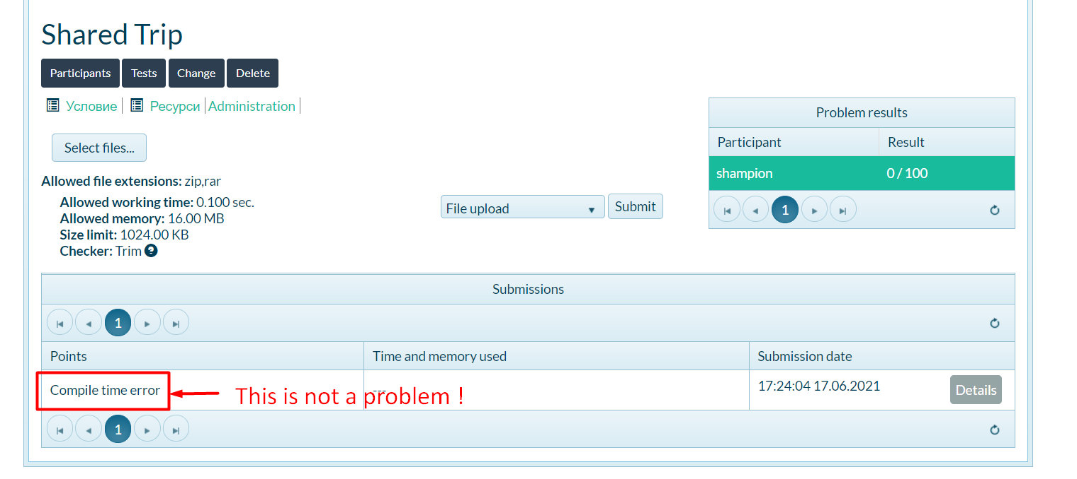

GOOD LUCK! 😊

